HONGIK UNIVERSITY
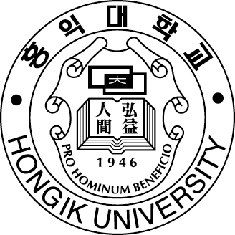

APPLICATION for Exchange Student

Please Attach a Photograph
International Center, HONGIK UNIVERSITY
72-1 Sangsu-dong, Mapo-gu, Seoul 121-791, KOREA

PERSONAL INFORMATION
Name : Gender : Male Female
 | Family | First
English
Korean(Optional)/
Chinese Character
(Japanese or Chinese only)
Resident Registration Number : Passport Number :
Nationality : China Place of Birth :
Date of Birth (M/D/Y) : E-mail Address :
Mailing Address :
Zip Code :
Telephone(in Korea or in Permanent Place) : Fax :

HOME INSTITUTION (Contact Information)

Home Institution (Major) Hubei Instittue of Fine Arts
Full Address : NO.6 Limiao Road, Cang Longdao, Jiangxia District, Wuhan City, China
Zip Code : 430205
Coordinator’s Name & Affiliation : Huang Chuanjian Foreign Affairs Office
Telephone : 0086-27-81317963 Fax : 0086-27-81317011
Signature of Approval :
Coordinator’s Signature | Date

STUDY INFORMATION
You must choose only one corresponding program.
R Undergraduate Program Graduate Program
Field of Study : Level of Study : Sophomore
Indicate Exchange Period(Semester/Year) : 2014--2015
Length of Study : One Semester R Two Semesters Others

LANGUAGE SKILL
If Korean is not your native language, have you ever studied Korean? Yes No
Indicate your level of proficiency
 | Advanced | Intermediate | Basic | None
Speaking
Reading
Writing
Indicate whether you want to learn Korean? Yes No

HOUSING INFORMATION
Accommodation Type : On-campus housing Off-campus housing Others :

APPLICANT’S SIGNATURE

Student’s Signature | Date

♣ Additional Documents to be Submitted:
- Autobiography (Personal Essay) & Statement of Purpose
- Official Transcript
- Recommendation Letter(1 or more)
- Portfolio (Where required)
- Passport Copy (please check the date of expiry)

